LAB ASSIGNMENT V : HUERISTIC EVALUATION
SYSTEM EVALUATED : Medsy
Groups members NAME : Riya Gupta,Anushka Ambadkar,Rushikesh Kokate
**Evaluation to be done by other Group
PART I : HUERISTIC EVALUATION BASED ON NIELSEN'S 10 GENERAL PRINCIPLES FOR INTERACTION DESIGN. (0 is lowest and 5 is highest)
S.No. | Heuristic Evaluation Parameter | Mention Violation if any | Severity 0-5 (0- minimum and 5 is maximium) | Ways to improve
1 | User Control: Interface will allow the user to perceive that they are in control | Good: breadcrumbs on the inner pages, a 'Back to Medicine Details' link, 'Clear all' for the filters and a quantity stepper, so users can always go back or reset.  Problem: there is no cart icon in the header, so we could not find any place to check or change what was added. 'Change location', 'Continue' (upload page) and 'View All' (doctors) are dummy '#' links and do nothing. | 2 | • Add a cart icon with an item count and a cart page where items can be edited or removed.  • Link the dummy buttons properly or remove them.
2 | Human Limitations: Interface will not overload the users cognitive, auditory and motor skills | The header has 9 main links plus Offers, Help & Support and Account, the home page has four sections stacked one after another, and the search page shows five filter groups before the first result, so it feels a bit crowded.  Good: the compare table (3 columns, 9 rows) is easy to read. | 2 | • Group some menu items (for example Ayurvedic and Health Products under one 'Shop' menu).  • Keep filters collapsed by default on phones and limit Quick Access to the 3 most used tasks.
3 | Accommodation: The interface will fit the way each user group works and thinks (personas) | The site fits people who take regular medicines well: Monthly Medicines, one-tap reorder, refill reminders and the prescription status steps.  Other user groups get little support: no language option, no text-size or accessibility settings, no caregiver/family profile, and no sign-in page (the 'Account' link just opens Health Records). | 2 | • Add a Hindi/Marathi language option and a larger-text mode.  • Add a sign-in page and family/caregiver profiles.
4 | Linguistic Clarity: Interface will communicate as efficiently as possible | The wording is simple and clear (for example 'Know when it arrives', 'Runs out in 5 days').  Small issues: the 'Care Plan' menu opens a page called 'Monthly Medicines'; 'Offers' opens the Health Products page; the 'Vitamins & Supple...' category name looks cut off; the compare page shows 'Manufacturer B' and 'Manufacturer C' as placeholder names. | 1 | • Make menu names match the page titles.  • Make a real Offers page, let long category names wrap, and use real manufacturer names.
5 | Aesthetic Integrity :The interface will have an attractive and appropriate design | The layout is neat and consistent: cards for each medicine, and price, stock and delivery time are easy to spot (judged from page content, since we could not take screenshots).  Emojis are used as icons everywhere (menu, categories, buttons). This looks a bit casual for a medical site and can look different on different devices. | 1 | • Use one consistent set of proper icons instead of emojis.  • Stick to a calm colour palette suited to healthcare.
6 | Simplicity: The interface will have a simple design | The main steps are short (search, product, compare, upload) and each page has one clear purpose.  Some repetition: Health Records shows the lab reports twice ('Lab Reports' and 'Recent Lab Reports'), 'Reorder' and 'Upload Prescription' appear in several places on the home page, and the header has 12 links. | 2 | • Remove the duplicate sections.  • Cut the header down to the main tasks and keep one main button per card.
7 | Predictability :The interface will behave in such a manner that the user can accurately predict what will happen next | Some links do not go where a user would expect. Every search result, including 'Glycomet 500mg Tablet', opens the same page ('Glycomet GP 1'). 'Help & Support' opens Consult Doctor, 'Account' opens Health Records, and 'Buy Now' and 'Choose this' (compare page) open the prescription upload page instead of a cart or checkout. | 3 | • Give each medicine its own detail page.  • Create proper Help and Account pages.  • Name buttons after what happens next (for example 'Upload prescription to continue').
8 | Accuracy: Interface will be free from errors | The information does not match across pages:  • 'Glycomet 500mg' costs ₹125 in search, but its page is Glycomet GP 1 at ₹112.50 (₹125 is shown as the MRP).  • Metformin 500 mg is ₹45 on Home but ₹92 in search, and Amlodipine 5 mg is a strip of 10 on Home but a strip of 5 in search.  • Home shows 3 monthly medicines of 30 tablets, but Care Plan shows 4 medicines of 15 tablets.  • Delivery is '25-35 min' on one page and 'by Today/Tomorrow' on another. Search says '120+ medicines found' but lists only 4.  • Searching 'Glycomet' shows Amlodipine as a 'Best Match'.  • The product page shows Metformin-only medicines as 'Same active ingredient' for a Metformin + Glimepiride tablet, which contradicts the compare page. For a medicine website this is a serious problem. | 4 | • Use one common product data source for all pages.  • Make alternatives match all active ingredients and strengths.  • Show the real result count and relevant results first.
9 | Technical Clarity: Interface will have the highest possible fidelity. | It works as a front-end prototype: all 12 pages open and link to each other, but the content is fixed. There is only one product page, the order (#MED12345) is hard-coded, and the pincode is 110001 while tracking shows a Pune address.  Many buttons are '#' placeholders (Change location, View/Download prescription, View Report, Shop Devices/Supplements/Personal Care, Learn more).  Limitation: we could not test whether Add to Cart, Reorder or Book Test actually do anything. | 3 | • Load the content from a data file using product IDs.  • Connect the unused buttons or mark them 'Coming soon'.
10 | Fulfillment : The interface will provide a satisfying user experience | The site does what the redesign promises: stock, delivery time and savings are visible before buying, the compare page shows how much you save (₹34.50 / ₹27.50) with a note to confirm with a pharmacist, and the track page has a clear step-by-step timeline.  But a user cannot finish an order from start to end, because we found no cart, checkout or payment page. | 2 | • Add the full flow: cart, address, payment and order confirmation.
11 | Consistency: Interface will be consistent | The header, breadcrumbs and cards look the same across the 12 pages we checked.  Inconsistent: button text ('Add to Cart' on search/products but 'Add' on Ayurvedic), price format (₹112.50 vs ₹125), and repeated menu targets (Offers = Health Products, Help & Support = Consult Doctor). | 2 | • Use the same button names and price format everywhere.  • Give each menu item its own page.
12 | User Support: Interface will provide additional assistance as needed or requested | 'Help & Support' takes you to Consult Doctor, and we found no FAQ, chat or contact details.  Some good support: the upload page says how long verification takes, the track page has a 'Contact Support' button (we could not check where it goes), and the compare page warns that a pharmacist or doctor may need to confirm a substitution.  There is no small help text for the filters or for generic alternatives. | 3 | • Add a Help Center with FAQs, order and prescription help, and a contact or chat option.  • Add short explanations next to filters and generic alternatives.
13 | Precision: The interface will allow the users to perform a task exactly | Good: filters for salt, strength, dosage form, availability and prescription, pack sizes (15/30/60) and a quantity stepper.  Limits: reorder is fixed at 'Quantity: 1 pack', 'Reorder All' cannot skip an item, and the delivery pincode cannot be changed because 'Change location' is a '#' link. | 2 | • Let users change the quantity and pick items before 'Reorder All'.  • Make the delivery location editable.
14 | Forgiveness: Interface will make action recoverable | Some actions can be undone: 'Clear all' for filters, back links and breadcrumbs, and the quantity - / + buttons.  We did not find a cart to remove items from, any confirmation or undo for 'Reorder', 'Reorder All' or 'Enable monthly reminders', a way to cancel an order, or a way to replace a wrongly uploaded prescription.  Limitation: we could not test how the buttons behave when clicked. | 3 | • Show a summary and ask for confirmation before 'Reorder All'.  • Add remove/undo in the cart, a cancel order option, and replace/remove file on the upload page.
15 | Responsiveness: The interface will inform users about the results of their actions and their interface status | Good: the track page shows the current step and 'Last updated: 4:35 PM', and the upload page shows a 3-step status.  Problems: the upload page already says 'Under Verification' before any file is chosen, which is confusing. We found no cart count or message after 'Add to Cart', and no upload progress or success/error message. Tracking is described as 'real time' but the page is static. | 3 | • Show the status only after a file is uploaded.  • Add a cart badge or small popup, upload progress, success/error messages and live tracking updates.
 | Total Score | Total = sum of the 15 severity scores (maximum 75). Average = 2.3 / 5. | 35 / 75

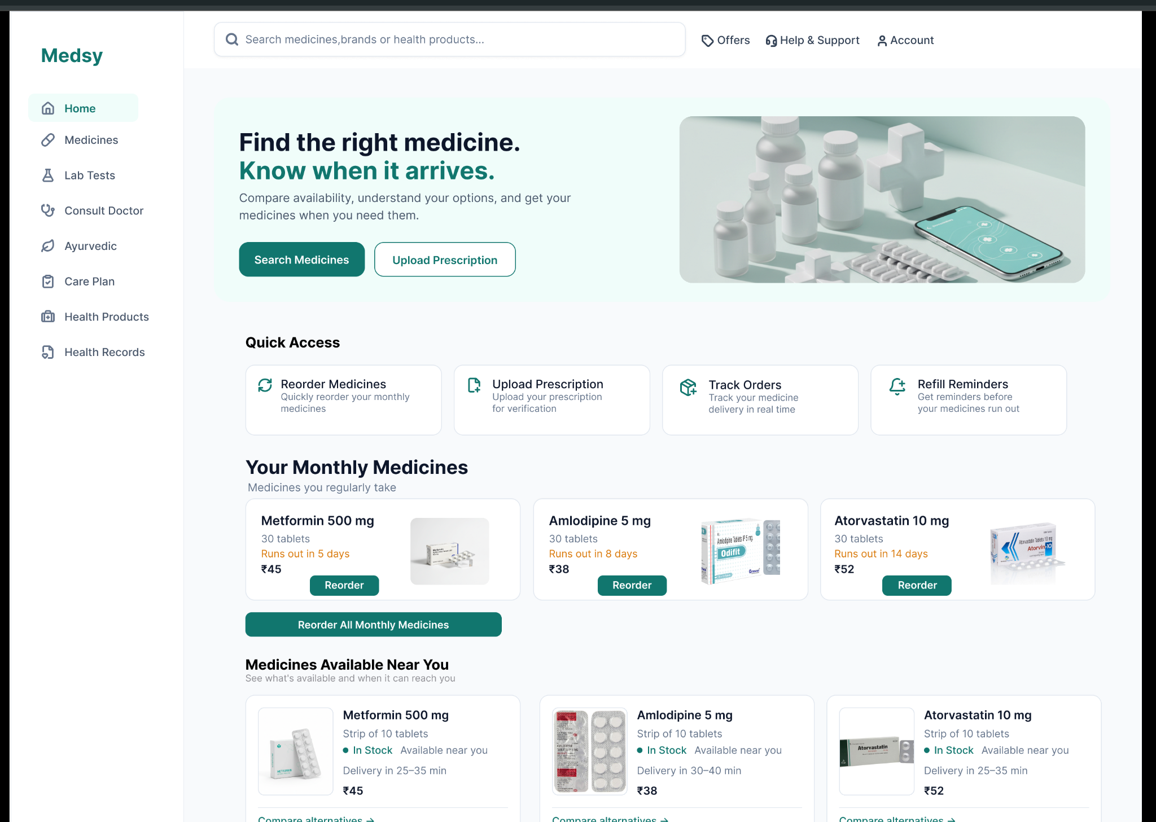
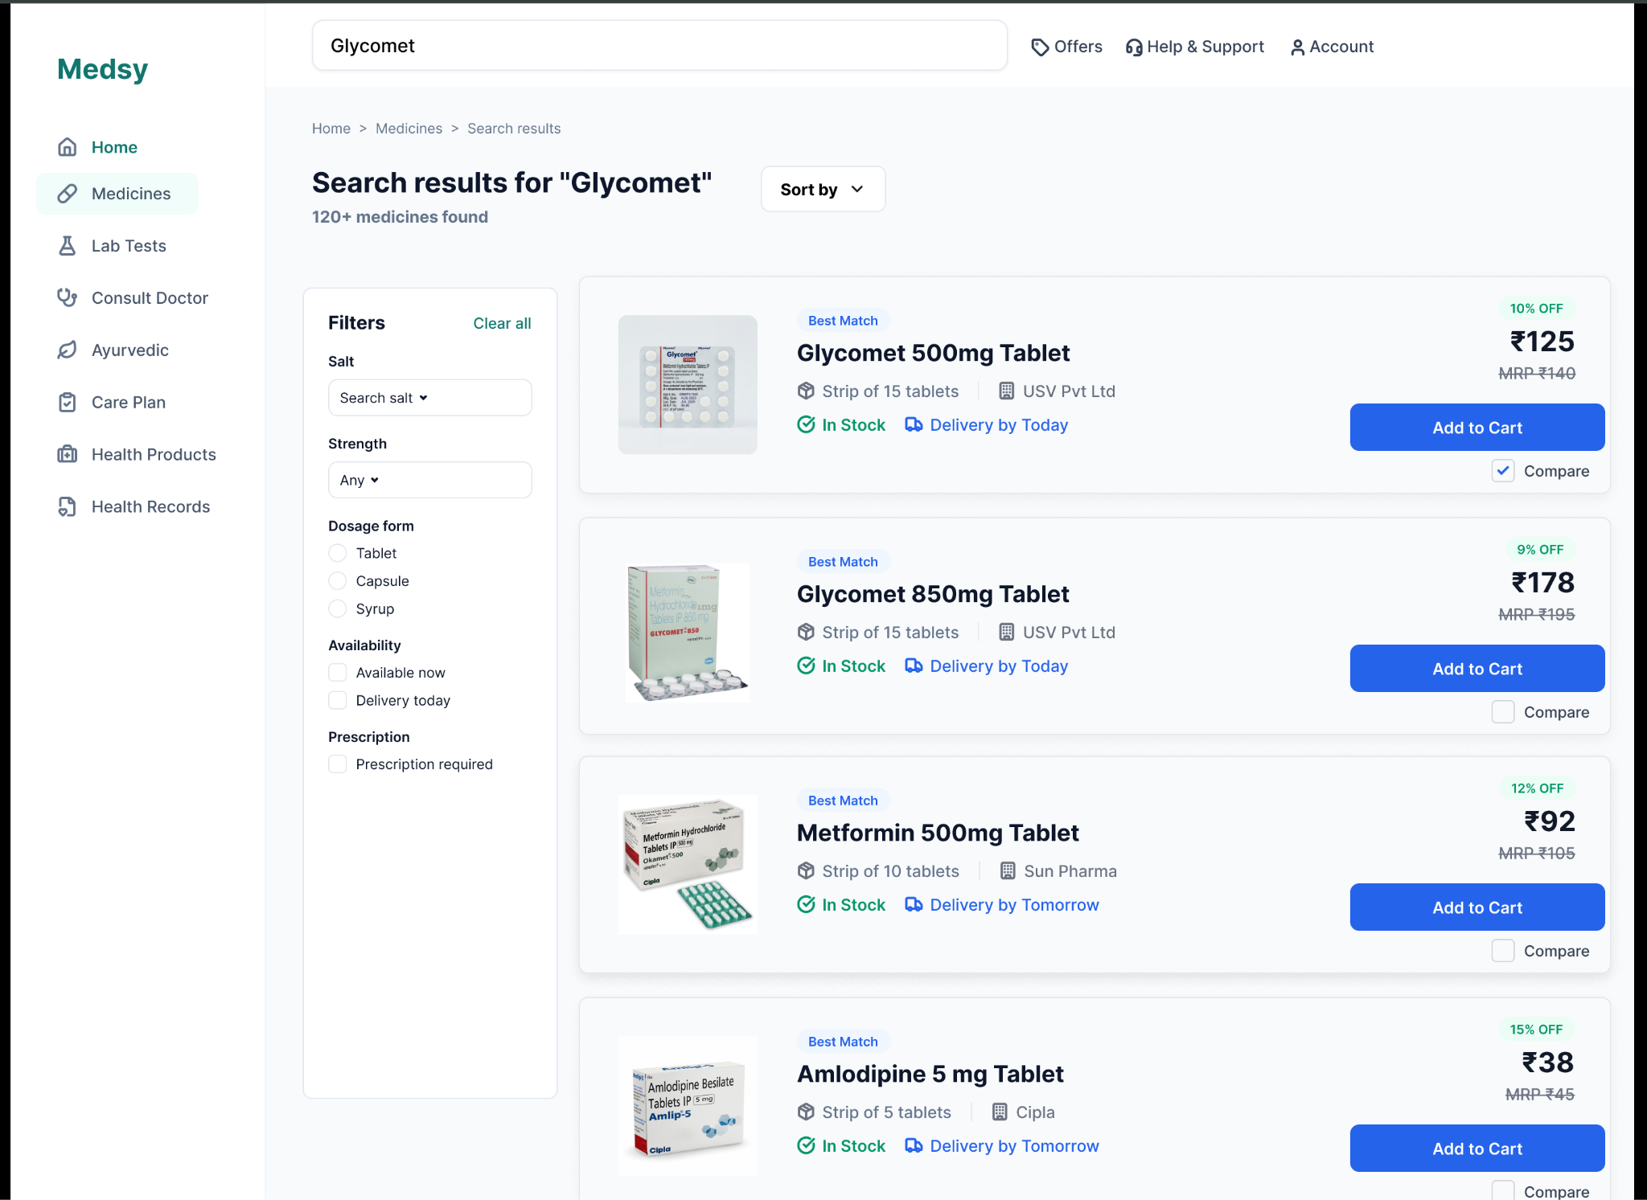
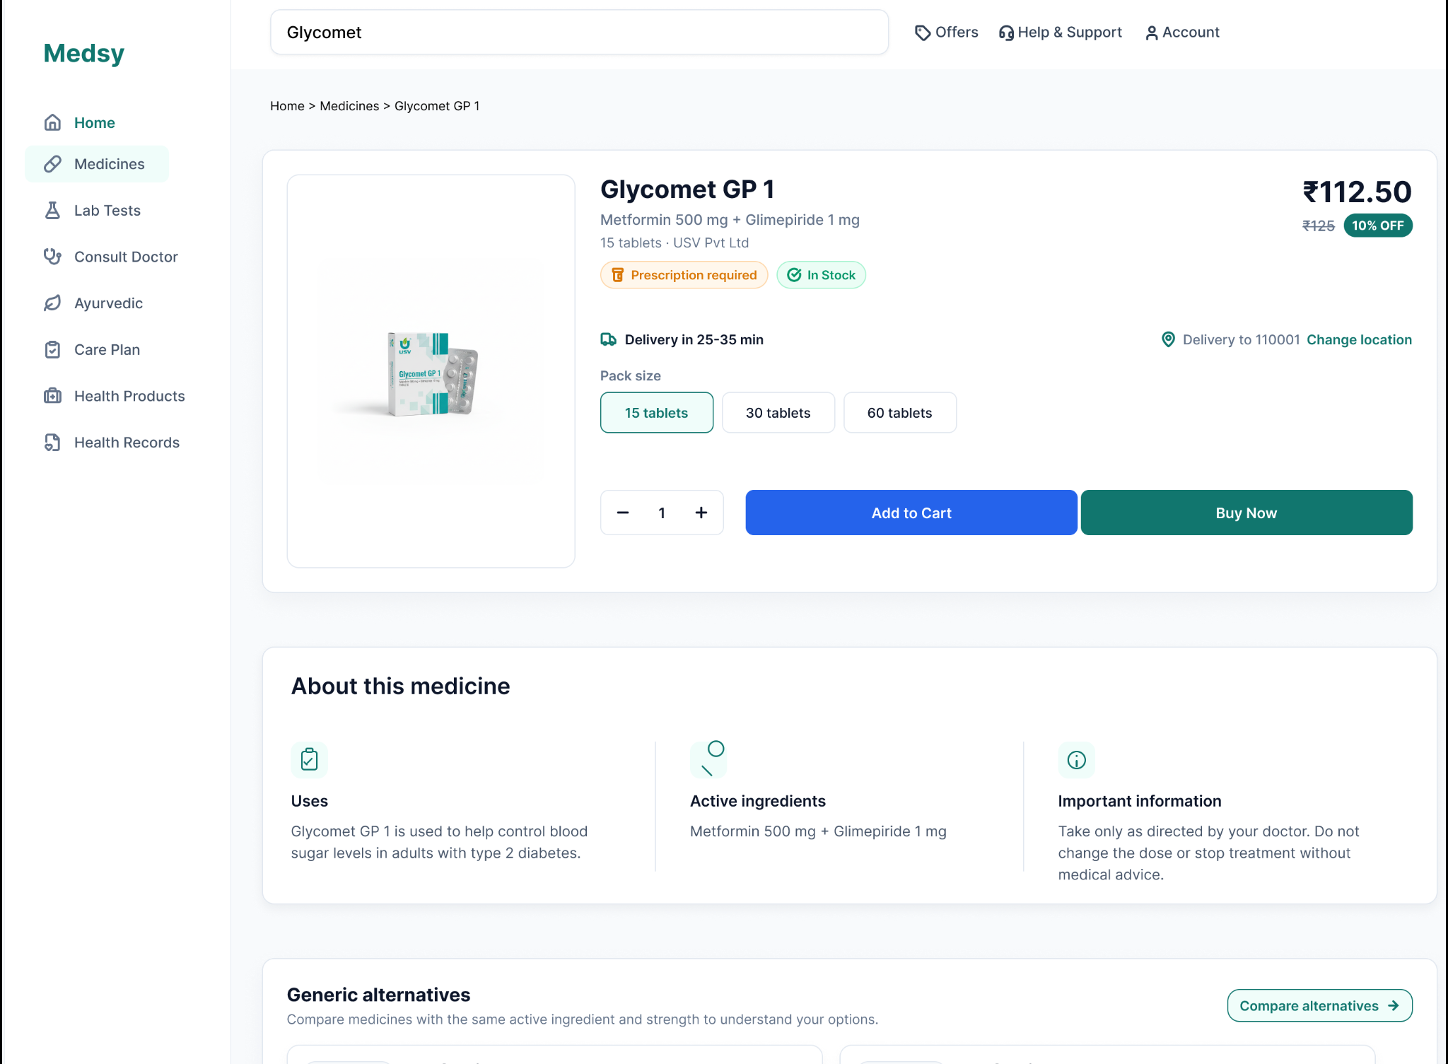
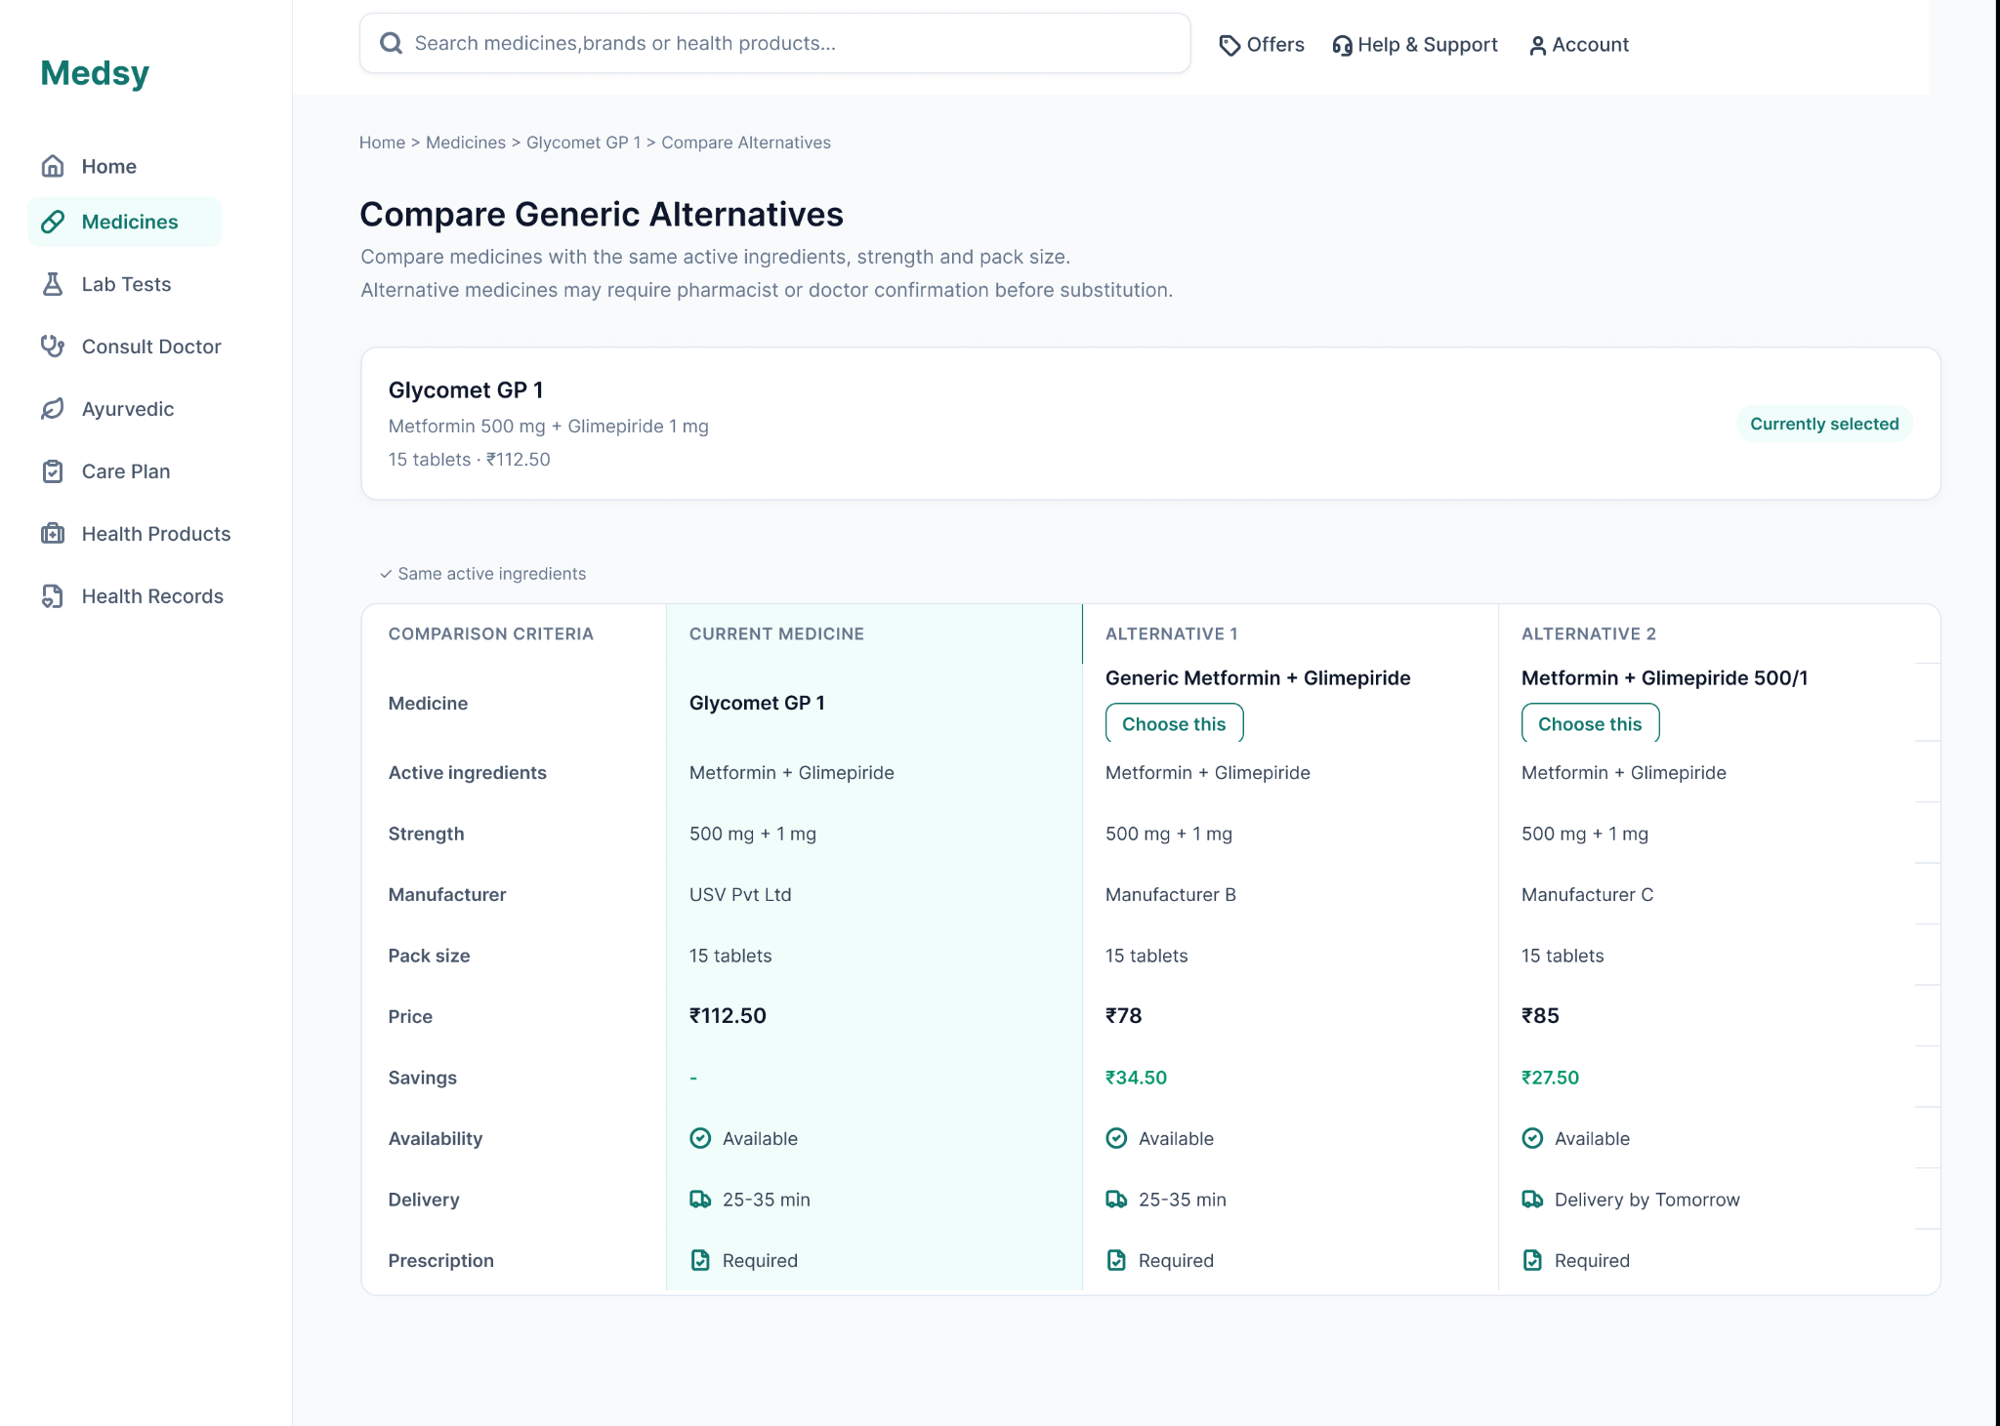
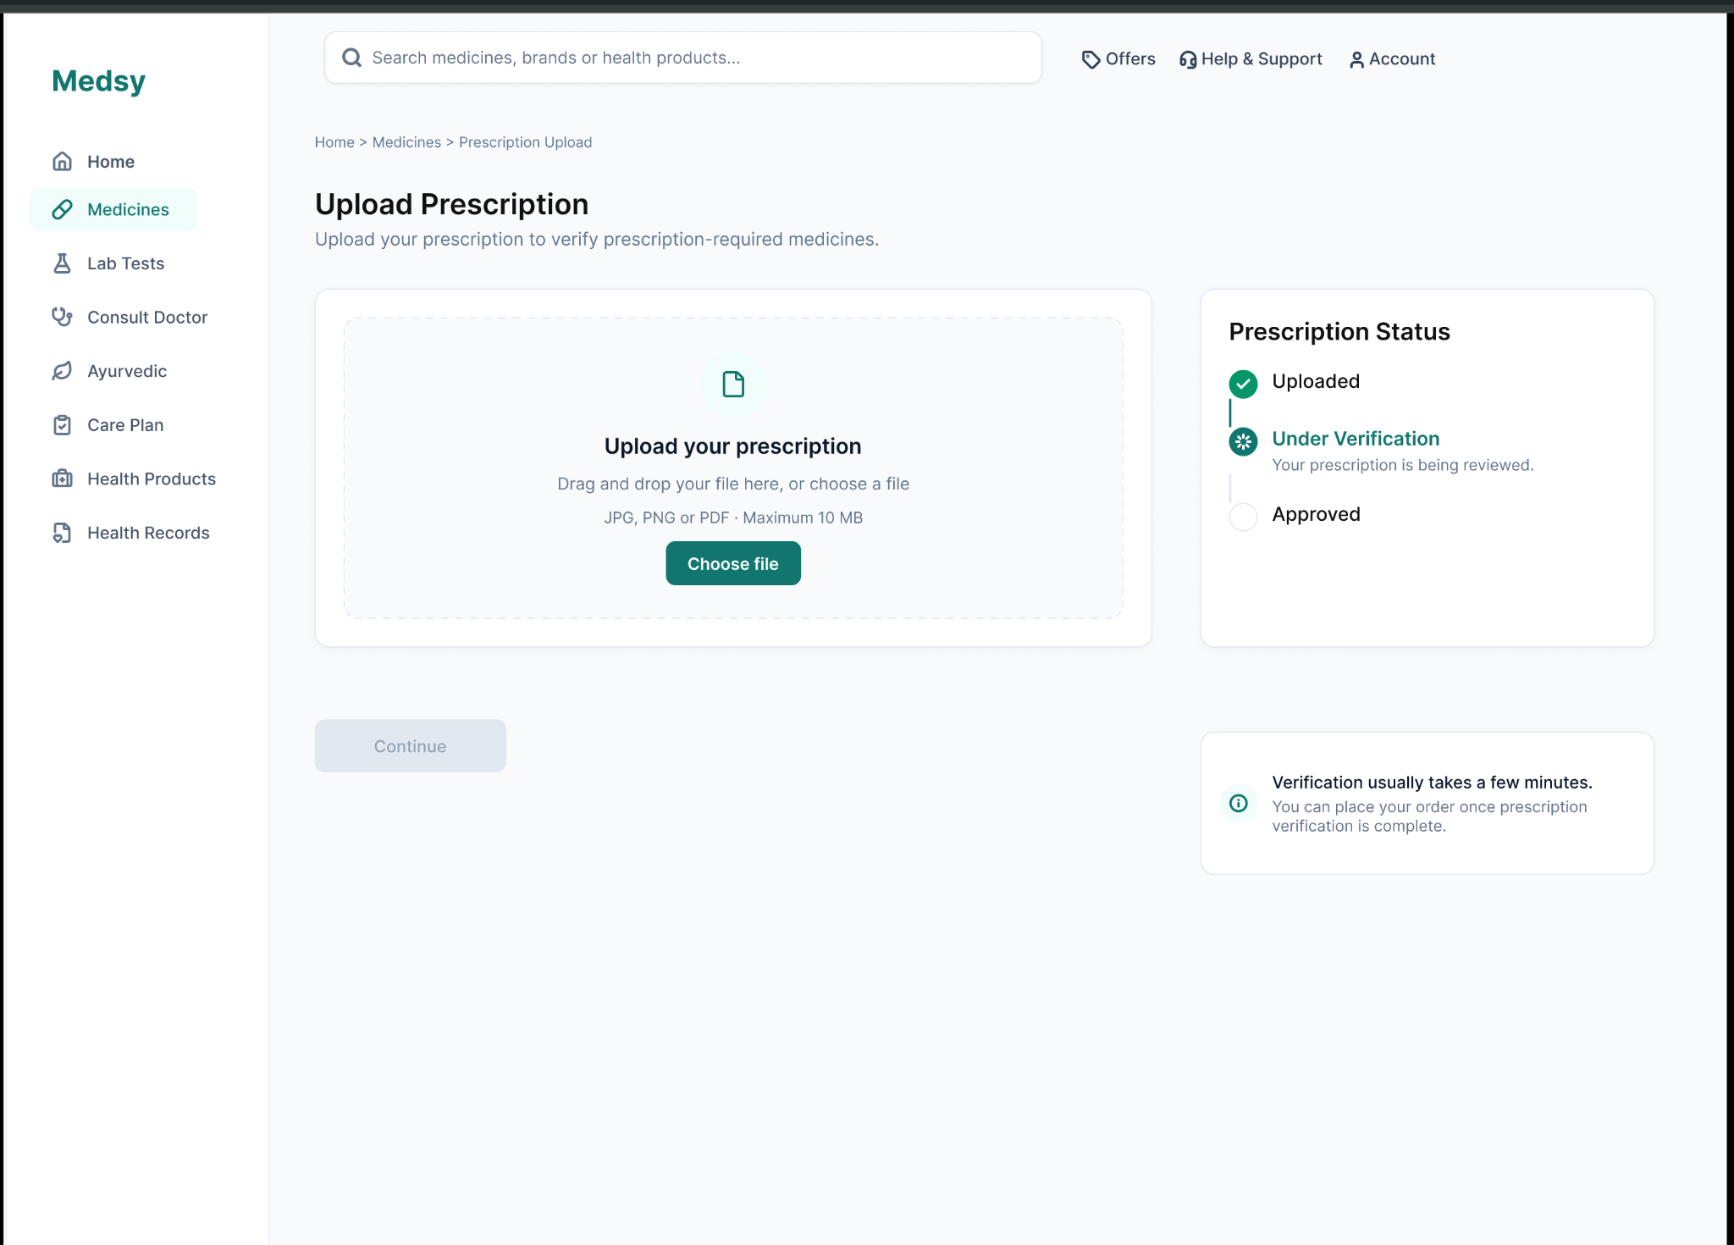
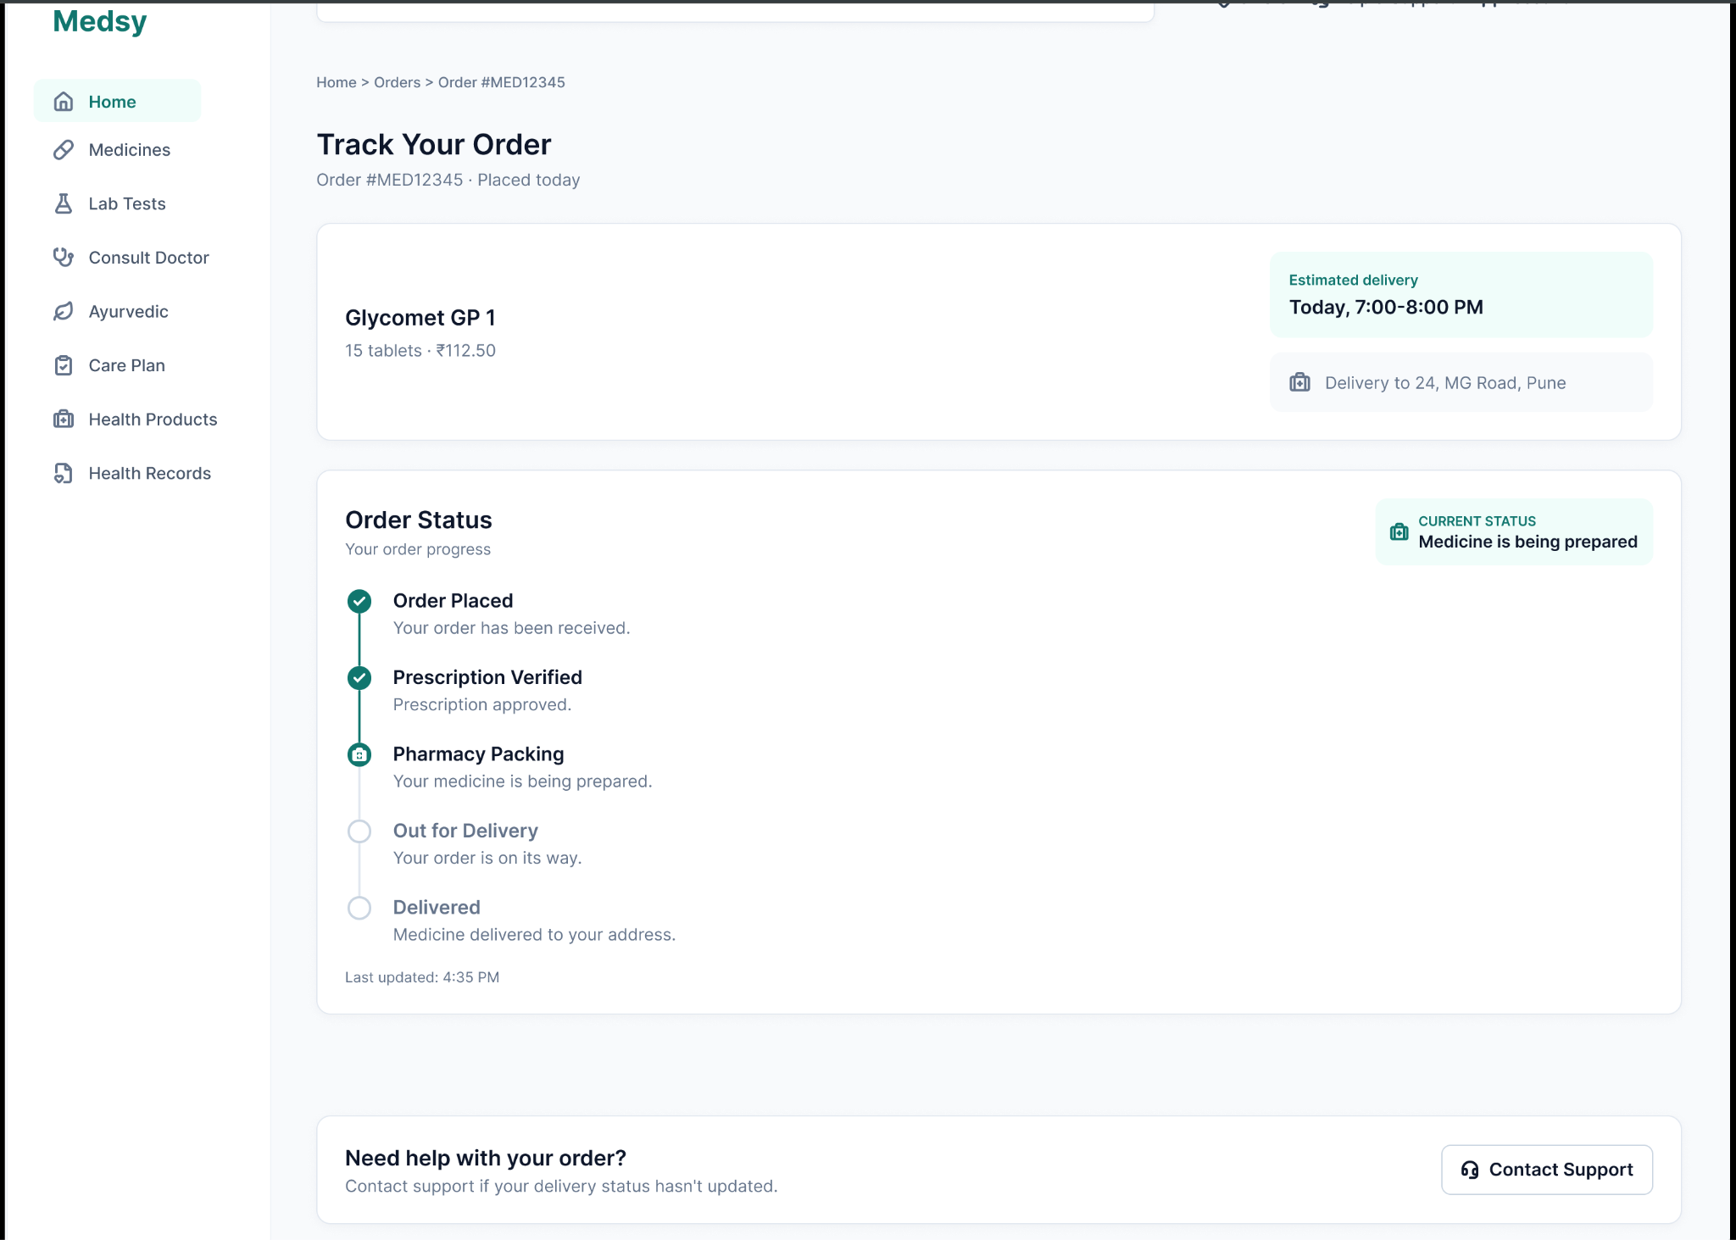
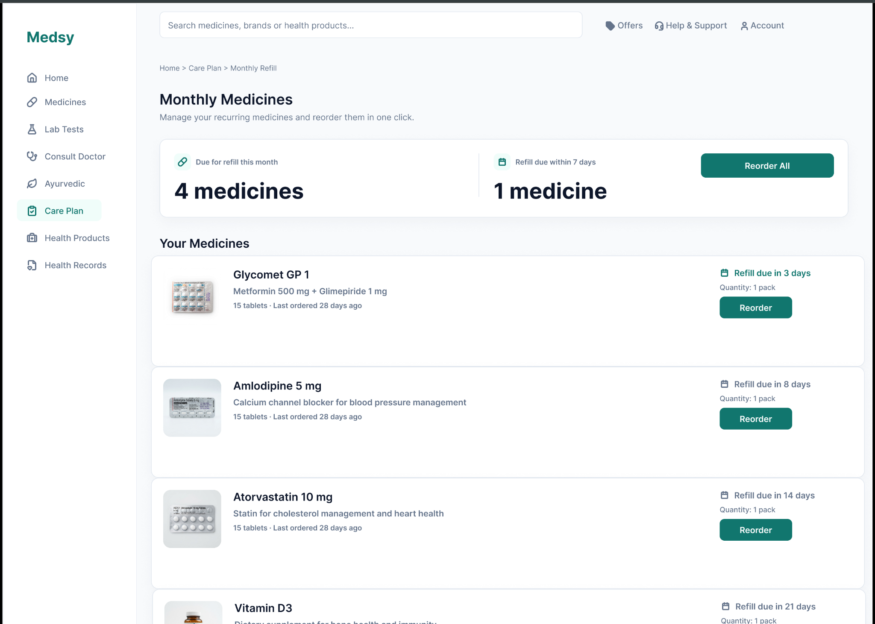
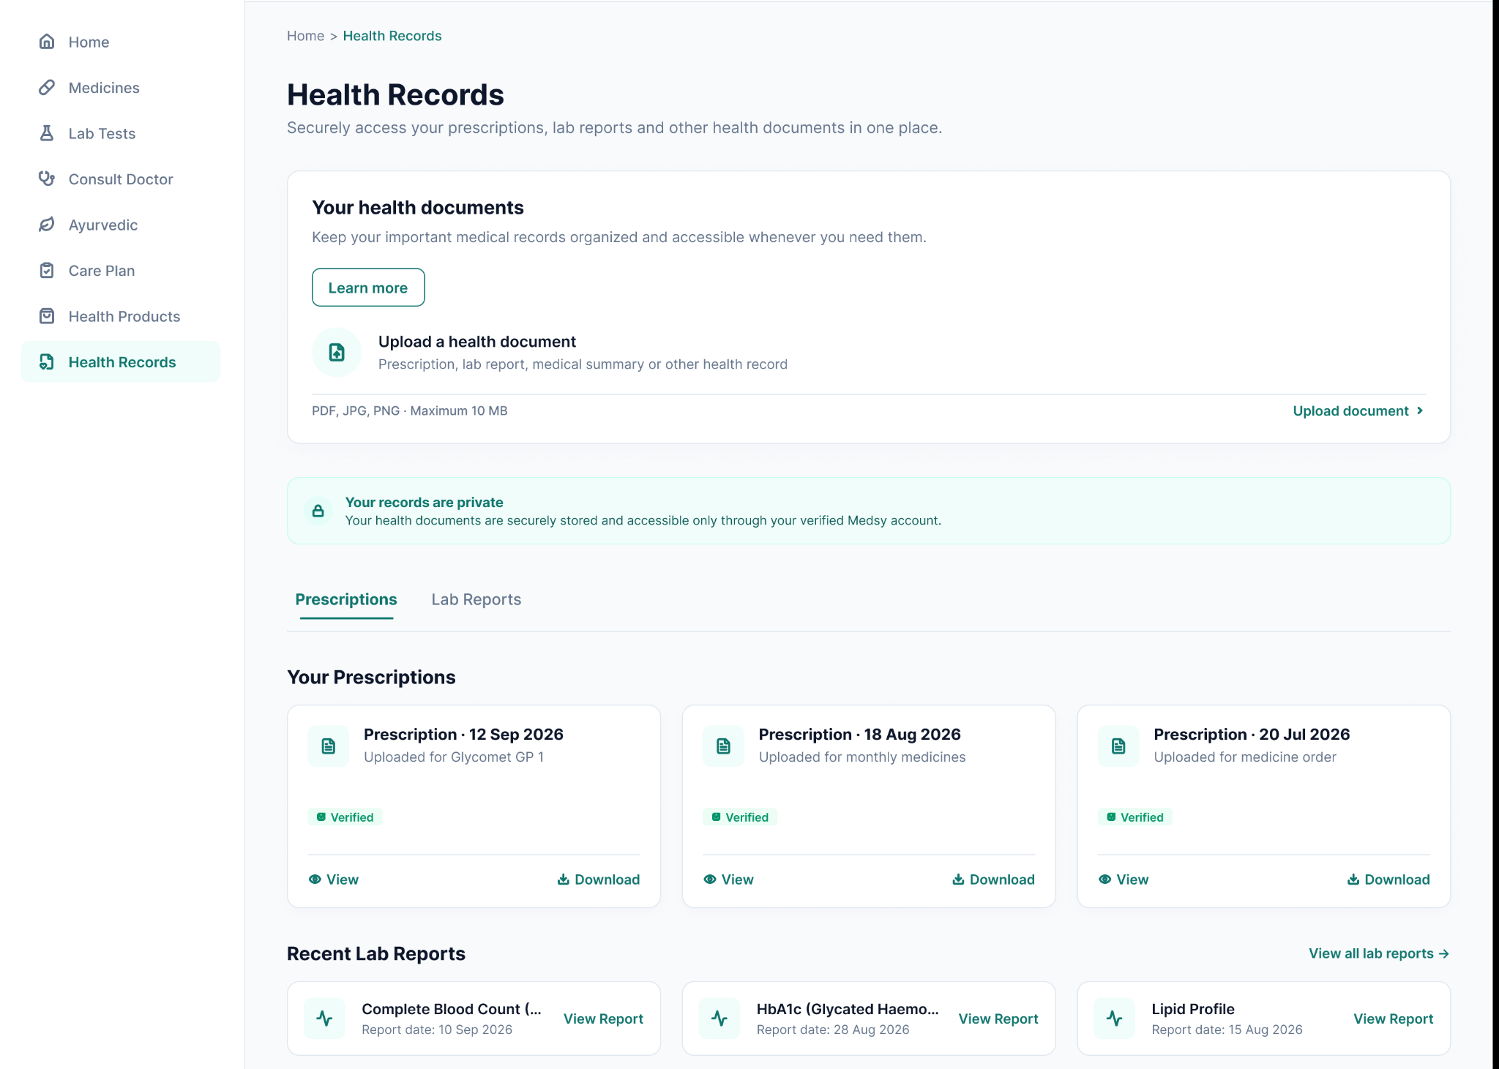

PART II : List out any other points that you may have missed out . (Other than Nielsen’s Principles)

S.NO | OBSERVATIONS | COMMENTS
1 | Accessibility (not covered in Part I) | Emojis are used as icons and labels everywhere, and screen readers may read them out in a confusing way. We did not test colour contrast, keyboard navigation or screen reader support.  Suggestion: Use proper labelled icons (hide the decorative ones from screen readers), check contrast against WCAG AA and test with the keyboard only.
2 | Navigation and header | The header has no cart, sign-in or wishlist. 'Account' and 'Help & Support' open other pages (Health Records, Consult Doctor).  Suggestion: Add cart and sign-in options and give Account and Help their own pages.
3 | Category tiles on Lab Tests and Ayurvedic pages | Tiles like 'Full Body Checkup' and 'Digestive Health' are not linked in the page code, unlike the category tiles on Home, so they look clickable but may not respond.  Suggestion: Link each tile to a filtered list, or style it so it does not look clickable.
4 | Search results page | The result cards do not show whether a prescription is needed (only the product page does), even though the filters have a 'Prescription required' option. It says '120+ medicines found' but shows 4, and we found no pagination.  Suggestion: Add an 'Rx' badge on the cards and show the correct count or add a 'Load more' option.
5 | Prescription flow | 'Buy Now' and 'Choose this' open the upload page without remembering which medicine was selected, and 'Continue' is a '#' link, so a prescription is never connected to an order.  Suggestion: Pass the selected medicine to the upload step and show it on that page.
6 | Health Records page | 'View', 'Download' and 'View Report' are '#' links, the lab reports are listed twice, and 'View all lab reports' points to '#t2'.  Suggestion: Remove the repeated list and link each report to a viewer or file.
7 | Mobile layout and trust information | Every page has a viewport tag, but we did not test the mobile layout. We also found no footer (about, licence, privacy, returns) on any page, even though the site deals with medical records.  Suggestion: Test at 360 to 414 px (menu collapse, tap size of at least 44 px) and add a footer with pharmacy licence, privacy and refund policy.

Students Evaluation Team : group that is evaluation ………………………………………………………………………………..

